**PHASE 3 - Data Modeling & Relationships**

**🔹Standard & Custom Objects**

**The data model utilizes both standard and custom objects to create a robust structure for the application.**

* **Standard Objects:**
  + **Contact: Represents the customer placing orders and making reservations.**
* **Custom Objects: Three new custom objects form the core of the application:**
  + **Order__c: Tracks all customer transactions.**
  + **Reservation__c: Manages table reservations.**
  + **Loyalty_Program__c: Holds customer loyalty point information.**

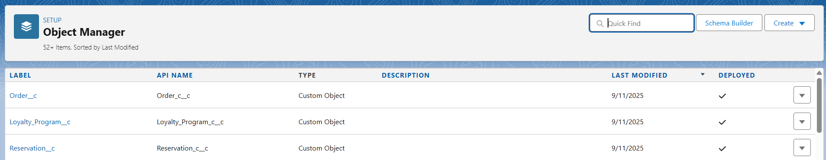

**🔹Fields & Relationships**

**Custom fields capture the required business data, and relationships link the objects together.**

* **Relationships:**
  + **Customer__c (Lookup to Contact): All three custom objects (Order__c, Reservation__c, Loyalty_Program__c) have a lookup relationship to the Contact object. This creates a customer-centric model where all activities are tied back to a single contact record. Lookup was chosen over Master-Detail to allow these records to exist independently of a Contact if needed in the future.**
* **Custom Fields:**

**On Order__c:**

* **Customer__c (Lookup to Contact)**
* **Order_Date__c (Date)**
* **Menu_Item__c (Picklist)**
* **Quantity__c (Number)**
* **Total_Amount__c (Currency)**
* **Status__c (Picklist: 'Pending', 'Complete', 'Cancelled')**

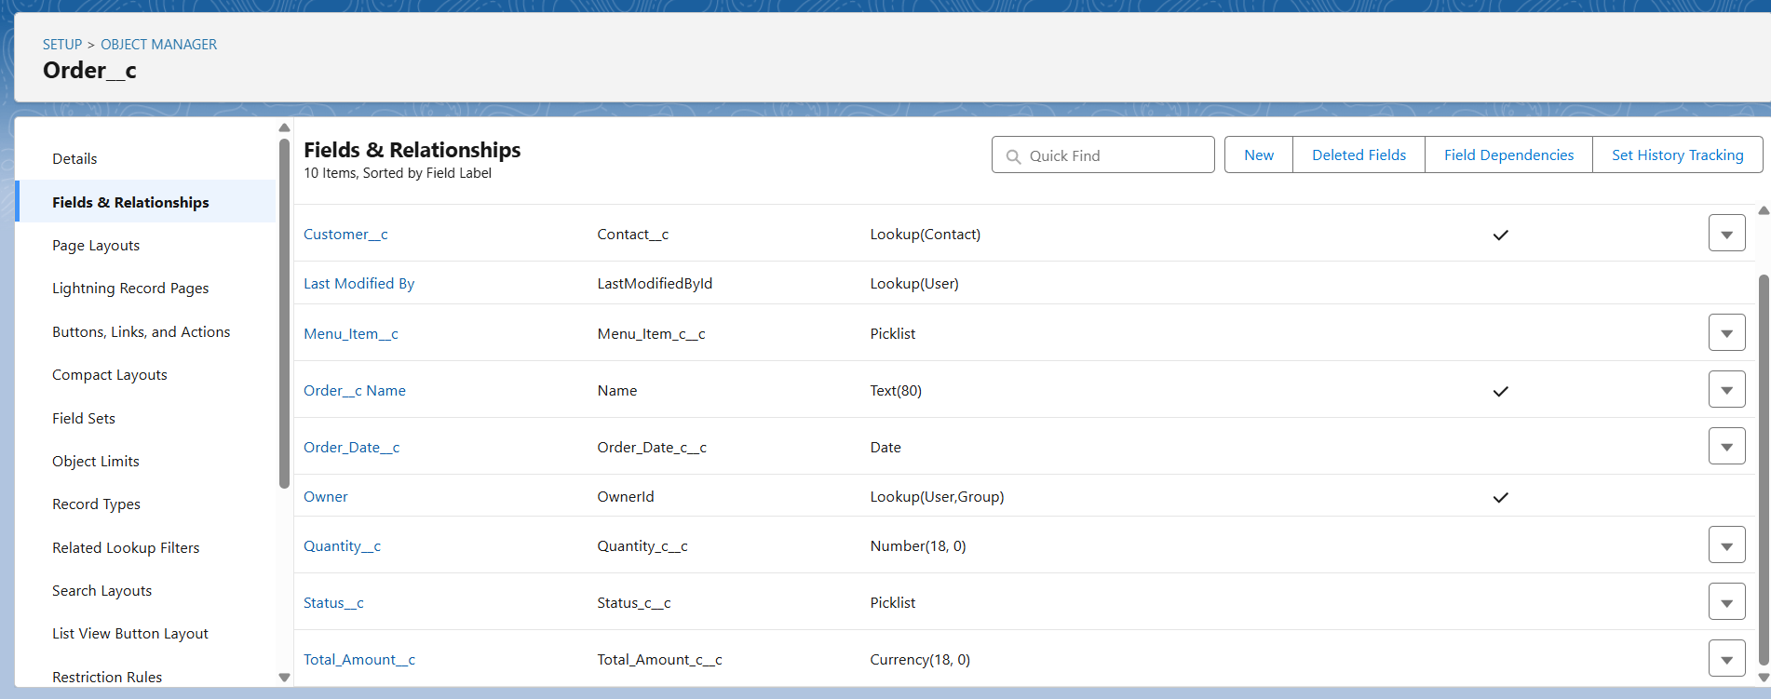

**On Reservation__c:**

* **Customer__c (Lookup to Contact)**
* **Reservation_Date__c (Date)**
* **Time_c (Time)**
* **Number_of_Guests__c (Number)**
* **Table_Number__c (Text)**

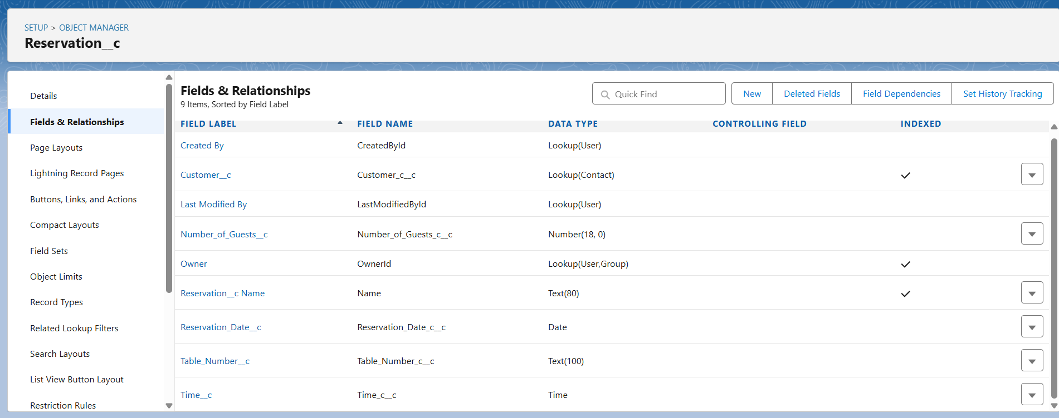

**On Loyalty_Program__c:**

* **Customer__c (Lookup to Contact)**
* **Points_Balance__c (Number, Default Value: 0)**
* **Last_Visited_Date__c (Date)**

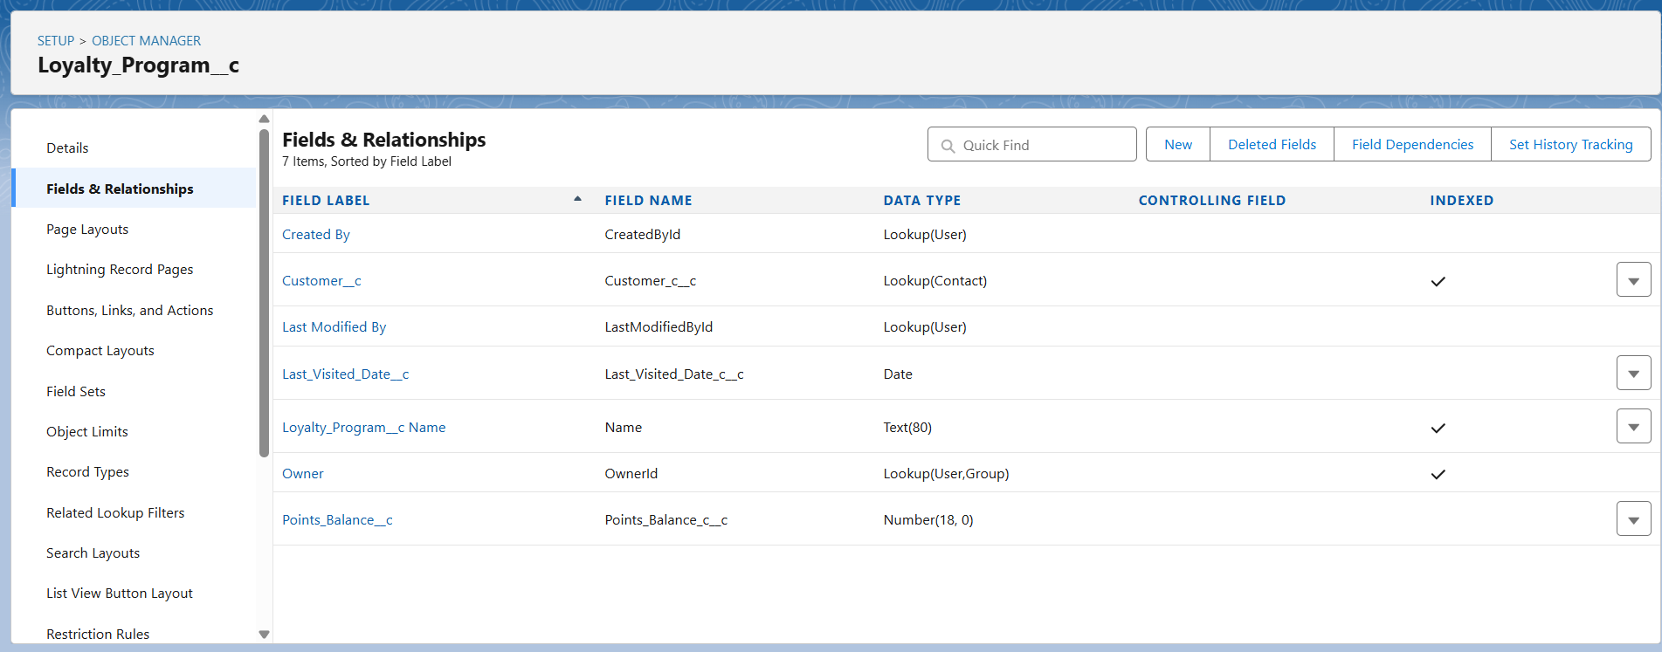

**🔹User Interface & Layouts**

**The on-screen display for records is controlled by various layout types.**

* **Page Layouts: A unique page layout for each custom object (Order, Reservation, Loyalty Program) will be created to organize fields and related lists for staff and managers.**

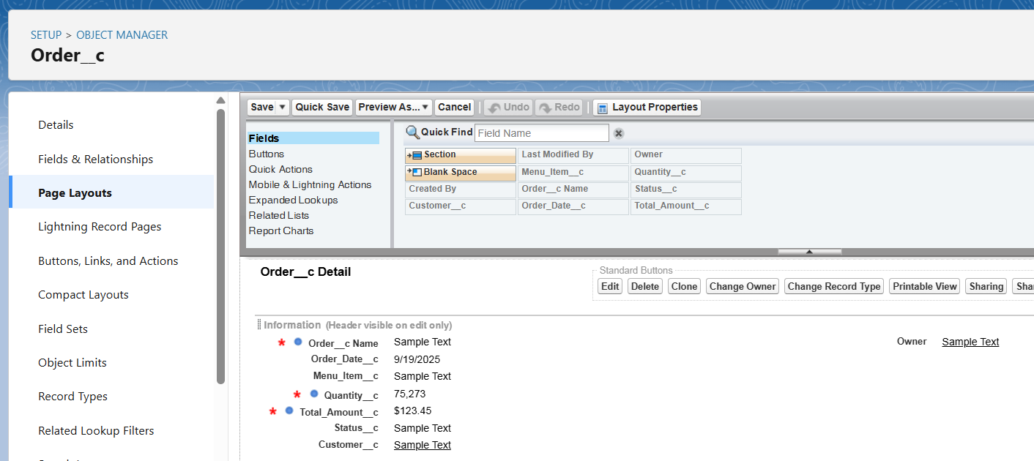

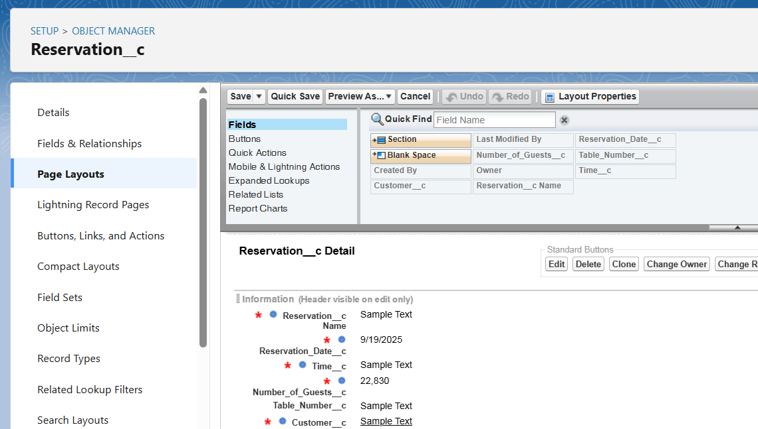

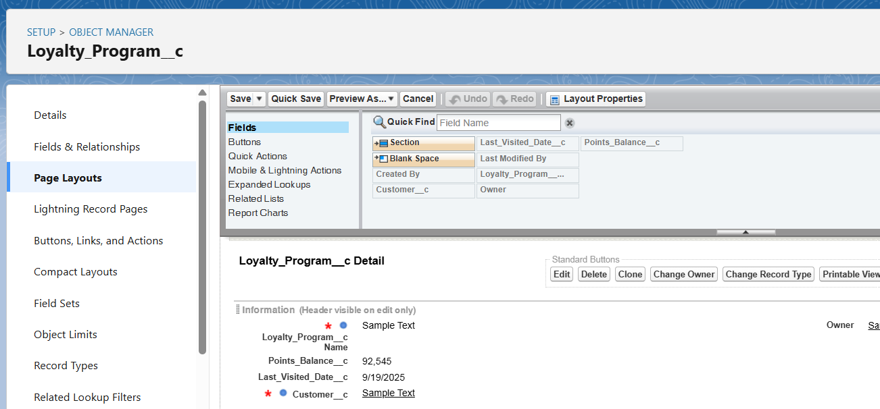

* **Compact Layouts: A compact layout for each object will be configured to display key fields in the record highlights panel and in the Salesforce mobile app. For example, the Order__c compact layout will show the Status__c and Total_Amount__c.**
* **Record Types: Initially, a single record type will be used for each object. In a future enhancement, we could create record types on the Order__c object like "Dine-In Order" and "Takeaway Order" to assign different page layouts or picklist values.**

**🔹Data Architecture**

* **Schema Builder: The Schema Builder tool will be used to visualize the complete data model, showing the Contact object at the center with lookups from Order__c, Reservation__c, and Loyalty_Program__c.**

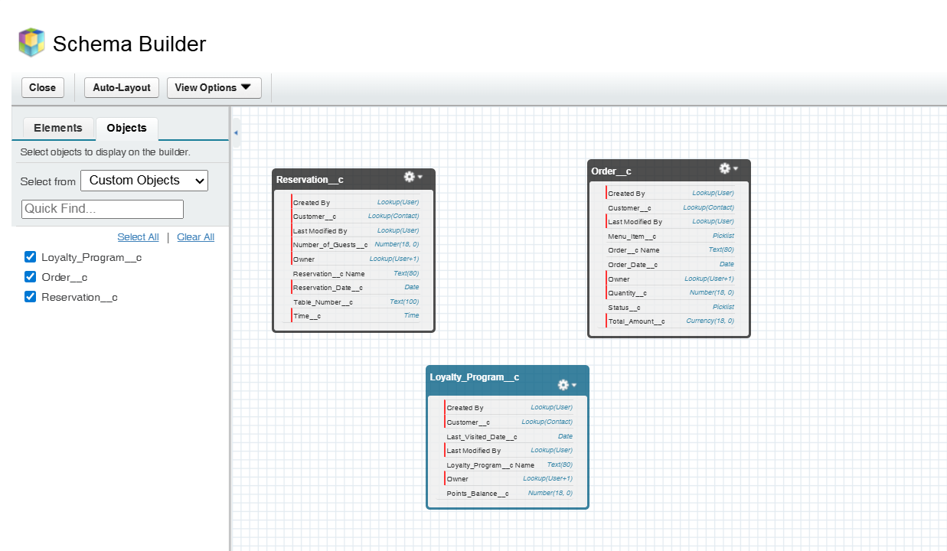

* **Junction Objects: A junction object is not required for the current design. However, if an Order__c needed to contain multiple Menu_Item__c records, a junction object called Order_Line_Item__c would be created with master-detail relationships to both Order__c and a new Menu_Item__c custom object.**